

Class Coding Test
Master of Computer Application
Semester – I

Sub: Front-End Frameworks and Technologies

Topic: LearnSmart – Educational Toys

By
Name: YUVRAJ PAARTH
Reg no: PROV/ASAC/MCA/7/26/083

Faculty Name: VEERA RAGHAV K

Faculty Signature: _______________

Department of Computer Application
Alliance University
Chandapura - Anekal Main Road, Anekal
Bengaluru - 562 106
August 2026

INDEX

sl no | Topics | Pg no
1 | Introduction | 2
2 | Input | 3-13
3 | Output | 14
4 | Conclusion | 15

INTRODUCTION
LearnSmart is a small e-commerce website for educational toys, built as part of my web development assignment. The idea is to help parents find toys that suit their child’s learning stage, so every toy shows the age group it is made for (1-3, 4-6 or 7-10 years).
The website is built with HTML5, CSS3 and JavaScript. It has a Home section, Categories based on age group, a Product List, Product Details and a Shopping Cart. Each toy has an image, a name, a price and a short description. The layout is kept simple and easy to read, and it adjusts to different screen sizes.

INPUT

<!DOCTYPE html>
<html lang="en">
<head>
<meta charset="UTF-8">
<meta name="viewport" content="width=device-width, initial-scale=1.0">
<title>LearnSmart - Educational Toys</title>
<link rel="stylesheet" href="css/style.css">
</head>
<body>

<header>
<h1>LearnSmart</h1>
<nav>
<a href="#home">Home</a>
<a href="#categories">Categories</a>
<a href="#products">Products</a>
<a href="#cart">Cart (<span id="cart-count">0</span>)</a>
</nav>
</header>
<section id="home">
<div class="home-text">
<h2>Educational toys for kids</h2>
<p>Toys that help children learn while they play. Every toy shows the age group it is made for.</p>
<a href="#products" class="button">Shop Now</a>
</div>
<img src="images/block.jpg" alt="Wooden ABC blocks">
</section>
<section id="categories">
<h2>Categories (by age group)</h2>
<button onclick="filterProducts('all')">All Toys</button>
<button onclick="filterProducts('1-3')">Ages 1-3</button>
<button onclick="filterProducts('4-6')">Ages 4-6</button>
<button onclick="filterProducts('7-10')">Ages 7-10</button>
</section>
<section id="products">
<h2>Products</h2>
<div id="product-list"></div>
</section>
<section id="details">
<h2>Product Details</h2>
<div id="detail-box"><p>Click "View Details" on a toy to see more about it.</p></div>
</section>
<section id="cart">
<h2>Shopping Cart</h2>
<div id="cart-box"></div>
<h3>Total: Rs. <span id="cart-total">0</span></h3>
</section>
<script src="js/script.js"></script>
</body>
</html>

CSS:
* {
margin: 0;
padding: 0;
box-sizing: border-box;
}

body {
font-family: Arial, sans-serif;
background-color: #f4f4f4;
color: #333;
line-height: 1.5;
}
header {
background-color: #2d6a4f;
color: white;
padding: 15px 30px;
display: flex;
justify-content: space-between;
align-items: center;
flex-wrap: wrap;
}
nav a {
color: white;
text-decoration: none;
margin-left: 20px;
}
nav a:hover {
text-decoration: underline;
}
section {
padding: 30px;
}
section h2 {
margin-bottom: 15px;
}
#home {
background-color: #d8f3dc;
padding: 50px 30px;
display: flex;
align-items: center;
justify-content: center;
gap: 40px;
flex-wrap: wrap;
}
.home-text {
max-width: 420px;
}
.home-text p {
margin-bottom: 20px;
}
#home img {
width: 260px;
max-width: 100%;
border: 1px solid #999;
}
.button {
background-color: #2d6a4f;
color: white;
padding: 10px 20px;
text-decoration: none;
border-radius: 4px;
}
button {
background-color: #2d6a4f;
color: white;
border: none;
padding: 8px 15px;
margin-right: 8px;
border-radius: 4px;
cursor: pointer;
font-size: 14px;
}
button:hover {
background-color: #1b4332;
}
/* products */
#product-list {
display: flex;
flex-wrap: wrap;
gap: 20px;
}
.product {
background-color: white;
border: 1px solid #ccc;
width: 240px;
padding: 15px;
text-align: center;
}
.product img {
width: 100%;
height: 180px;
object-fit: contain;
background-color: white;
}
.product h3 {
margin: 10px 0 5px;
}
.age {
color: #666;
font-size: 14px;
}
.price {
font-weight: bold;
margin: 8px 0;
}
/* details */
#details {
background-color: white;
}
.detail {
display: flex;
gap: 25px;
flex-wrap: wrap;
}
.detail img {
width: 250px;
max-width: 100%;
}
/* cart */
table {
width: 100%;
border-collapse: collapse;
background-color: white;
margin-bottom: 15px;
}
th, td {
border: 1px solid #ccc;
padding: 8px;
text-align: center;
}
th {
background-color: #d8f3dc;
}
td button {
margin: 0 2px;
padding: 4px 10px;
}
footer {
background-color: #2d6a4f;
color: white;
text-align: center;
padding: 15px;
}
@media (max-width: 600px) {
header {
flex-direction: column;
}
nav a {
margin: 0 8px;
}
.product {
width: 100%;
}
th, td {
font-size: 13px;
padding: 5px;
}
}

JS:
// list of products
var products = [
{
id: 1,
name: "Wooden ABC Blocks",
age: "1-3",
price: 799,
image: "images/block.jpg",
description: "Wooden blocks with letters and bright colours. Easy for small hands to hold and stack."
},
{
id: 2,
name: "Rainbow Stacking Rings",
age: "1-3",
price: 549,
image: "images/rings.jpeg",
description: "Colourful rings that stack on a pole. Helps toddlers learn sizes and colours."
},
{
id: 3,
name: "Picture Puzzle Set",
age: "4-6",
price: 649,
image: "images/puzzle.jpeg",
description: "Thick jigsaw puzzle pieces with animal pictures. Good for matching shapes and solving problems."
},
{
id: 4,
name: "Bead Counting Frame",
age: "4-6",
price: 899,
image: "images/abacus.jpeg",
description: "A simple abacus with sliding beads. Helps children learn counting and basic addition."
},
{
id: 5,
name: "Mini Science Lab Kit",
age: "7-10",
price: 1499,
image: "images/science.jpeg",
description: "A kit with a flask and test tubes for easy and safe experiments at home."
},
{
id: 6,
name: "Build-a-Robot Kit",
age: "7-10",
price: 1999,
image: "images/Build-a-Robot kit.jpeg",
description: "Snap-together robot with 120 pieces. Helps with logical thinking and following instructions."
}
];

// cart holds objects like { id: 1, qty: 2 }
var cart = [];
function getProduct(id) {
for (var i = 0; i < products.length; i++) {
if (products[i].id == id) {
return products[i];
}
}
}
// show products on the page (filtered by age group)
function filterProducts(age) {
var output = "";
for (var i = 0; i < products.length; i++) {
var p = products[i];
if (age == "all" || p.age == age) {
output += '<div class="product">';
output += '<img src="' + p.image + '" alt="' + p.name + '">';
output += '<h3>' + p.name + '</h3>';
output += '<p class="age">Age group: ' + p.age + ' years</p>';
output += '<p class="price">Rs. ' + p.price + '</p>';
output += '<button onclick="showDetails(' + p.id + ')">View Details</button>';
output += '<button onclick="addToCart(' + p.id + ')">Add to Cart</button>';
output += '</div>';
}
}
document.getElementById("product-list").innerHTML = output;
}
// show details of one product
function showDetails(id) {
var p = getProduct(id);
var output = '<div class="detail">';
output += '<img src="' + p.image + '" alt="' + p.name + '">';
output += '<div>';
output += '<h3>' + p.name + '</h3>';
output += '<p>Age group: ' + p.age + ' years</p>';
output += '<p>Price: Rs. ' + p.price + '</p>';
output += '<p>' + p.description + '</p><br>';
output += '<button onclick="addToCart(' + p.id + ')">Add to Cart</button>';
output += '</div></div>';
document.getElementById("detail-box").innerHTML = output;
document.getElementById("details").scrollIntoView();
}
function addToCart(id) {
for (var i = 0; i < cart.length; i++) {
if (cart[i].id == id) {
cart[i].qty++;
showCart();
return;
}
}
cart.push({ id: id, qty: 1 });
showCart();
}
function changeQty(id, amount) {
for (var i = 0; i < cart.length; i++) {
if (cart[i].id == id) {
cart[i].qty += amount;
if (cart[i].qty <= 0) {
cart.splice(i, 1);
}
break;
}
}
showCart();
}
function removeFromCart(id) {
for (var i = 0; i < cart.length; i++) {
if (cart[i].id == id) {
cart.splice(i, 1);
break;
}
}
showCart();
}
// draw the cart table and update the total
function showCart() {
var total = 0;
var count = 0;
if (cart.length == 0) {
document.getElementById("cart-box").innerHTML = "<p>Your cart is empty.</p>";
} else {
var output = "<table>";
output += "<tr><th>Product</th><th>Price</th><th>Quantity</th><th>Subtotal</th><th>Remove</th></tr>";
for (var i = 0; i < cart.length; i++) {
var p = getProduct(cart[i].id);
var subtotal = p.price * cart[i].qty;
total += subtotal;
count += cart[i].qty;
output += "<tr>";
output += "<td>" + p.name + "</td>";
output += "<td>Rs. " + p.price + "</td>";
output += '<td><button onclick="changeQty(' + p.id + ', -1)">-</button> ' + cart[i].qty + ' <button onclick="changeQty(' + p.id + ', 1)">+</button></td>';
output += "<td>Rs. " + subtotal + "</td>";
output += '<td><button onclick="removeFromCart(' + p.id + ')">X</button></td>';
output += "</tr>";
}
output += "</table>";
document.getElementById("cart-box").innerHTML = output;
}
document.getElementById("cart-total").innerText = total;
document.getElementById("cart-count").innerText = count;
}
// run when page loads
filterProducts("all");
showCart();

OUTPUT

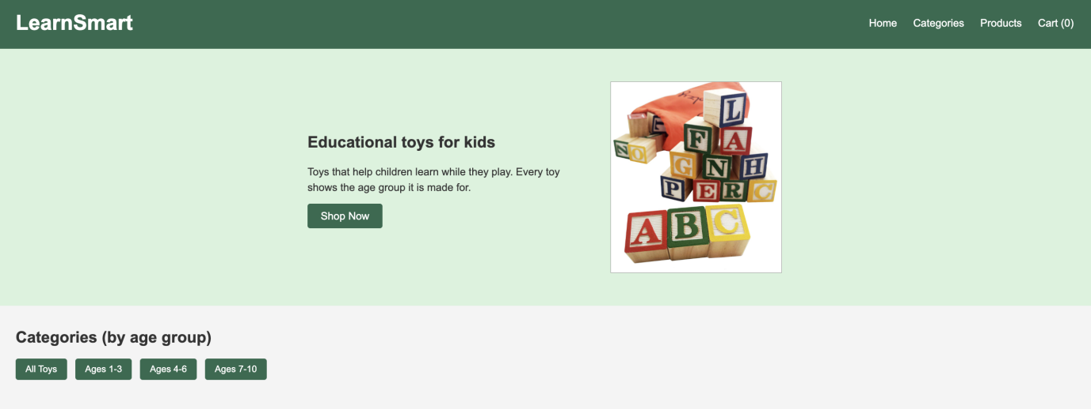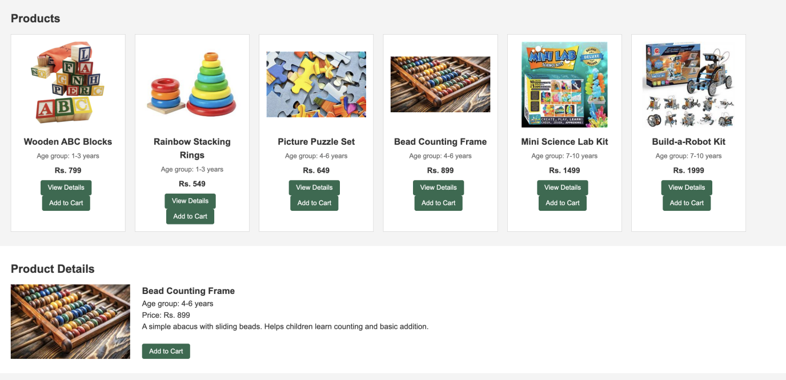

CONCLUSION

This project helped me understand how a basic online shopping page works. I used HTML for the structure, CSS for the colours, layout and responsive design, and JavaScript to filter toys by age group, show product details and manage the cart. The cart lets the user add toys, increase or decrease the quantity, remove items, and see the total price update automatically.
While building it, I learned how to show data on a page using JavaScript and how to keep the design consistent across all sections. I also tested each feature in the browser, including the category buttons, Add to Cart, quantity changes and the total.
The website works as a basic store, but it could be improved. In the future, I could add a search option, a checkout page and a way to save the cart after the page is refreshed. I could also connect it to a database so the products are not stored directly in the code.

